*Brendan Rushing*

*6020895*

*September 25,2018*

*relational databases assignment #1*

PROG2110

# Installation

The server and client do not require installation.

They can be opened by double clicking on the executable files.

**Server**

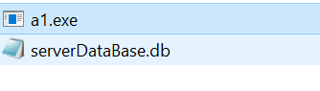

Figure 0

**Client**

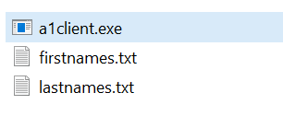

Figure 9

### Server

The server can be opened by double clicking on the “server.exe” file. See figure 10.

The server will show a console terminal with the IP Address and Port # that the server is listening on.

The client will need to enter this information to connect.

The server displays the number of users connected on the console window.

The server can be closed by pressing the x button or ctrl + c.

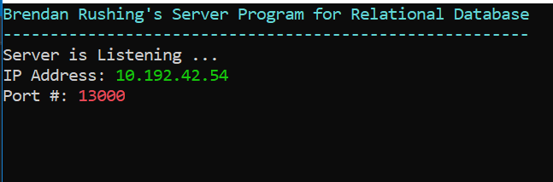

Figure 6

## Client

The client can be opened by double clicking on the “client.exe” file. See figure 9.

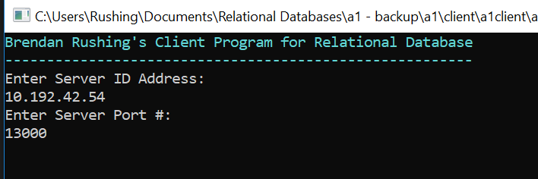

Figure 2

The client will then prompt the user to enter the IP Address and Port # that the server is listening on. See Figure 1.

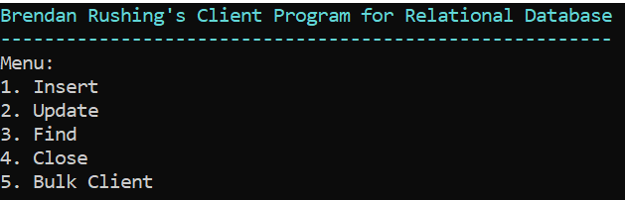

Figure 3

The user will then be shown a menu prompting the user to enter a number to start the function. See Figure 2.

1. Insert
2. Find
3. Update
4. Close
5. Bulk Client

### Insert

The insert function allows the user to add a new entry to the database. The user will need to enter a first name, last name and date of birth.

The first name and last name are restricted to a maximum of 25 characters.

The date needs to be in the format of YYYY-MM-DD (ex: 1991-08-15).

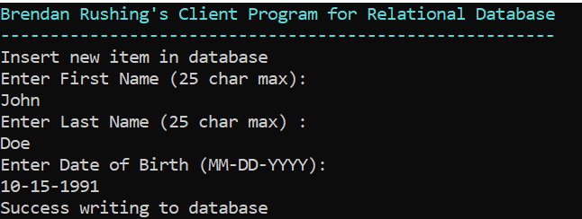

Figure 4

The data entry will be sent remotely to the server after the user enters the date of birth.

The server will then return one of the following messages to the client:

* Successfully inserted entry into the database
* Server Error
* Server Error – Full 40,000 entries in server

The user will then be returned the main menu.

### Find

The find function allows the user to find entries in the server database by entering the member ID.

The server will then return the database entry to the client if it is found in the database and it will be displayed on the screen.

The client will display an error message if the member ID could not be found.

The following data entries will be shown on the screen:

* Member ID
* First name
* Last name
* Date of birth

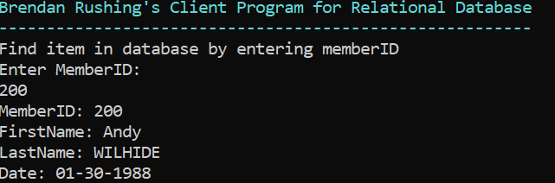

Figure 5

### Update

The update function allows the user to update entries in the server database by entering the member ID, first name, last name and date of birth of an entry already stored in the database.

The client will display an error message if the entry could not be found.

The user will be prompted to enter new information for the database entry if it is found in the server.

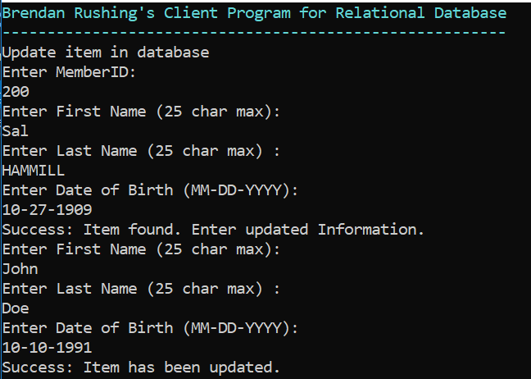

Figure 6

### Bulk Client

The bulk client function allows the user to insert entries into the database by using a list of random first names and last names. The client also generates a random date of birth.

The items are sent to the server one at a time and the user can set the number of items to be sent. This is a good way to test simultaneous users accessing the database at once.

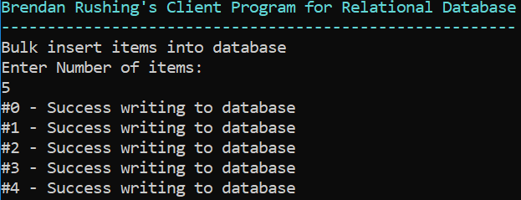

Figure 7